

**PowerEnJoy Project**



**Project Plan Document**

**(PPD)**

Alfredo Maria Fomitchenko (mat. 874656)

Version: 1.0

Release date: 22 January 2017

1. Introduction 3

1.1 Purpose and Scope 3

1.2 List of Definitions and Abbreviations 3

1.3 List of Reference Documents  4

2. Project size, cost and effort estimation 5

2.1 Size estimation: Function Points 5

2.1.1 Internal Logic Files (ILFs) 5

2.1.2 External Interface Files (EIFs) 7

2.1.3 External Inputs (EIs) 9

2.1.4 External Inquiries (EQs) 10

2.1.5 External Outputs (EOs) 10

2.1.6 Overall estimation 11

2.2 Cost and Effort Estimation: COCOMO II 12

2.2.1 Scale drivers 13

2.2.2 Cost drivers 16

3. Schedule and resource allocation 27

4. Risk management 29

5. Effort 32

6. Changelog 33

# Introduction

## Purpose and Scope

This project aims to provide customers within the administrative division of Milan with a car sharing service and all the associated functionalities as widely illustrated throughout the RASD, DD, and ITPD.

This Project Plan Document, is intended as a non-definitive guideline for the future Project Manager to estimate costs and effort, define the budget, allocate resources and keep track of the project progress.

## List of Definitions and Abbreviations

In extension to the RASD, DD and ITPD Definitions, acronyms, abbreviations paragraphs, below are some definitions and abbreviations used in this document:

* “FP” = acronym for Function Points
* “ILF” = acronym for Internal Logic File
* “EIF” = acronym for External Interface File
* “EI” = acronym for External Input
* “EO” = acronym for External Output
* “EQ” = acronym for External Enquiries

## List of Reference Documents

I used for this PP as reference for the project assignment, the general layout and structure

* Assignments AA 2016-2017.pdf,
* RASD v1.1 Alfredo Fomitchenko.pdf,
* DD v1.1.1 Alfredo Fomitchenko.pdf,
* ITPD v1.0.1 Alfredo Fomitchenko.pdf,
* Project planning example document.pdf;

for the Gantt chart

* GanttProject 2.8.1;

to write the actual document

* Microsoft Word 2016;

as scheduling and time effort management tracker

* Microsoft Excel 2016.

# Project size, cost and effort estimation

## Size estimation: Function Points

### Internal Logic Files (ILFs)

The provided service relies on stored information needed to be retrieved, analyzed and processed.

The ILFs identified are the following:

* Login data, simple pairs of email addresses and associated passwords.
* Customer data, all the information associated to the customer provided during the registration process, including the credit card number necessary for the charge process at the end of a ride;
* Car data, including identification number, license plate, position and battery charge;
* Reservation data, linking a customer with the corresponding reserved car;
* Ride data, linking a customer with the corresponding car in usage.

Overall the complexity of each ILF is not concerning, therefore I obtain the following count:

|  |  |  |
| --- | --- | --- |
| ILF | Complexity | FPs |
| Login data | Low | 7 |
| Customer data | Low | 7 |
| Car data | Low | 7 |
| Reservation data | Low | 7 |
| Login data | Low | 7 |
| Total |  | 35 |

### External Interface Files (EIFs)

Even though the system relies upon three main external services, only one of them provides a significant stream of data:

1. the Email Service Provider is asked to send an email, and this provides a simple positive or negative answer;
2. the system asks to charge the customer via the Bank through a RESTful HTTPS request, and as for the Email Service Provider it simply answers back;
3. when requested, Google Maps provides a stream of data via GeoCoding, GeoLocation and Google Maps Javascript APIs that require complex parsing and elaboration.

To be also considered within the scope of External Interface Files there is another element of this project that represents a fundamental peculiarity.

As discussed in the RASD External Interface Requirements paragraph and DD Architectural Design section, the system infrastructure includes an Android Auto car service pre-installed onto the employed cars which controls and checks along with the application server itself the validity and authenticity of the car unlock request and allows the customer to enter it just after every possible non-fraudulency check.

State-of-the-art Android Auto system only allows to “passively” run onto the car screen applications that are actually running onto the smartphone plugged into the car connectors, therefore the development and deployment of such background independent service will require a Google partnership.

The complexity of this aspect, as a matter of new pioneering Android Auto accomplishment, is considered of course high.

Following are the External Interface Files counts:

|  |  |  |
| --- | --- | --- |
| EIF | Complexity | FPs |
| GeoCoding data | High | 10 |
| GeoLocation data | High | 10 |
| Google Maps Javascript API data | High | 10 |
| Android Auto car service | High | 10 |
| Total |  | 40 |

### External Inputs (EIs)

The customer can interact with the system through the following requests:

* Login, a simple operation in which comparing the information provided by the customer and the information stored in the database;
* Placing a reservation, a not so simple call that starts an associated reservation timer, creates the reservation linking customer and car and setting the car unavailable;
* Unlocking a car, which starts the complex communication between the system and the car service responsible for the unlocking process;
* Terminating a ride, that not only starts the locking process but also stops the ride timer triggering the credit card charge request.

Following are the External Inputs counts:

|  |  |  |
| --- | --- | --- |
| EI | Complexity | FPs |
| Login | Low | 2 |
| Placing a reservation | Medium | 4 |
| Unlocking a car | High | 6 |
| Terminating a ride | High | 6 |
| Total |  | 18 |

### External Inquiries (EQs)

The data retrieval performed by the customer regards the reservation process: in fact,

* the customer is able to retrieve the available cars list, operation that involves the Google Maps Javascript API necessary for the car positions rendering onto the map inside the mobile application, therefore this operation is considered to be complex;
* the customer is able to retrieve his reservation placed beforehand when he is willing to unlock the car. This operation is fairly simple and does not require much effort by the system components.

The resulting counts are the following:

|  |  |  |
| --- | --- | --- |
| EQ | Complexity | FPs |
| Available cars retrieval | High | 6 |
| Reservation retrieval | Low | 3 |
| Total |  | 9 |

### External Outputs (EOs)

The system does not need to communicate with the customer outside the context of an inquiry.

### Overall estimation

The estimation activity yields to the following table:

|  |  |
| --- | --- |
| Function type | FPs |
| Internal Logic Files | 35 |
| External Interface Files | 40 |
| External Inputs | 18 |
| External Inquiries | 9 |
| External Outputs | 0 |
| Total | 102 |

Mobile application has not been included in the cost estimation because it just represents a negligible system service presentation effort.

Considering Java Enterprise Edition as a development platform, according to <http://www.qsm.com/resources/function-point-languages-table> the total number of source lines of code has a range between

$$SLOC=102*46=4692$$

and

$$SLOC=102*67=6834$$

## Cost and Effort Estimation: COCOMO II

At first the cost estimation had been made with considered only one fictional partner to help me with the project, but the final figures for the development duration happened to be prohibitive.

What follows is the cost and effort analysis including two Politecnico di Milano students as partners.

### Scale drivers

I refer to the following official COCOMO II table in order to evaluate the scale drivers:

|  |  |  |  |  |  |  |
| --- | --- | --- | --- | --- | --- | --- |
| Scale Factors | Very Low | Low | Nominal | High | Very High | Extra High |
| PREC | thoroughly unprecedented 6.20 | largely unprecedented 4.96 | somewhat unprecedented 3.72 | generally familiar  2.48 | largely familiar  1.24 | thoroughly familiar  0.00 |
| FLEX | rigorous  5.07 | occasional relaxation  4.05 | some relaxation  3.04 | general conformity  2.03 | some conformity  1.01 | general goals  0.00 |
| RESL | little  (20%)  7.07 | some  (40%)  5.65 | often  (60%)  4.24 | generally  (75%)  2.83 | mostly  (90%)  1.41 | full  (100%)  0.00 |
| TEAM | very difficult interactions  5.48 | some difficult interactions  4.38 | basically cooperative interactions  3.29 | largely cooperative  2.19 | highly cooperative  1.10 | seamless interactions  0.00 |
| PMAT | Level 1  Lower  7.80 | Level 1  Upper  6.24 | Level 2  4.68 | Level 3  3.12 | Level 4  1.56 | Level 5  0.00 |

* PREC: abbreviation for Precedentedness, reflects the previous experience of our team with the development of large scale projects. Even though I am confident my partners will have way more skills than me, as a Mathematical Engineering Bachelor Degree graduate this represents my first computer science related project, so that this scale driver cannot be higher than the value representing the low level;
* FLEX: abbreviation for Development Flexibility, reflects the degree of flexibility in the development process with respect to the external specification and requirements. The presence of very strict assumptions and therefore requirements puts this value to very low;
* RESL: abbreviation for Risk Resolution, reflects the level of awareness and reactiveness with respect to risks. Since risks have been analyzed but a small team cannot be physically enough reactive to overcome every issue, this value will be nominal;
* TEAM: abbreviation for Team Cohesion, an indicator of how well the team members know each other and work together in a cooperative way. This value will be very high: my 9-month real-world work experience as an intern at the Vodafone Italy IT department, which my manager evaluated very positively, made me gain profound awareness of my team-work skills.
* PMAT: abbreviation for Process Maturity. As mentioned previous experiences of managing such big projects are limited for me, so this value will be low.

The evaluation is the following:

|  |  |  |
| --- | --- | --- |
| Scale driver | Factor | Value |
| PREC | Low | 4.96 |
| FLEX | Very Low | 5.07 |
| RESL | Nominal | 4.24 |
| TEAM | Very High | 1.10 |
| PMAT | Nominal | 4.68 |
| Total |  | 20.05 |

### Cost drivers

|  |  |  |  |  |  |  |
| --- | --- | --- | --- | --- | --- | --- |
| Cost driver | Very Low | Low | Nominal | High | Very High | Extra High |
| RELY | slightly inconvenience  0.82 | easily recoverable losses  0.92 | moderate  recoverable losses  1.00 | high financial loss  1.10 | risk to human life  1.26 | n/a |

* RELY: abbreviation for Required Software Reliability. From a business point of view, especially at the beginning, profit margins will be very low so a simple malfunctioning will lead to important financial losses. Therefore this value is set to high.

|  |  |  |  |  |  |  |
| --- | --- | --- | --- | --- | --- | --- |
| Cost driver | Very Low | Low | Nominal | High | Very High | Extra High |
| DATA | n/a | $$\frac{D}{P}<10$$ 0.90 | $$10≤\frac{D}{P}<100$$ 1.00 | $$100≤\frac{D}{P}<1000$$ 1.14 | $$\frac{D}{P}≥1000$$ 1.28 | n/a |

* DATA: abbreviation for Database Size. As highlighted in the Internal Logic Files paragraph, stored information are very simple, and a quick estimation yields to a worst-scenario upper bound of 1GB database. Therefore D/P is between 146 and 213, putting the cost driver to a high value.

|  |  |  |  |  |  |  |
| --- | --- | --- | --- | --- | --- | --- |
| Cost driver | Very Low | Low | Nominal | High | Very High | Extra High |
| CPLX | 0.73 | 0.87 | 1.00 | 1.17 | 1.34 | 1.74 |

* CPLX: abbreviation for Product Complexity. Set to nominal according to the COCOMO II rating scale.

|  |  |  |  |  |  |  |
| --- | --- | --- | --- | --- | --- | --- |
| Cost driver | Very Low | Low | Nominal | High | Very High | Extra High |
| RUSE | n/a | None  0.95 | Across project  1.00 | Across program  1.07 | Across product line  1.15 | Across multiple product lines  1.24 |

* RUSE: abbreviation for Required Reusability. Since this project is not related to other branches, this value is set to nominal.

|  |  |  |  |  |  |  |
| --- | --- | --- | --- | --- | --- | --- |
| Cost driver | Very Low | Low | Nominal | High | Very High | Extra High |
| DOCU | Many life-cycle needs uncovered  0.81 | Some life-cycle needs uncovered  0.91 | Right-sized to life-cycle needs  1.00 | Excessive for life-cycle needs  1.11 | Very excessive for life-cycle  needs  1.23 | n/a |

* DOCU: abbreviation for Documentation Match to Life-Cycle Needs. Documentation foresees every need of the product life-cycle, therefore this value is set to nominal.

|  |  |  |  |  |  |  |
| --- | --- | --- | --- | --- | --- | --- |
| Cost driver | Very Low | Low | Nominal | High | Very High | Extra High |
| TIME | n/a | n/a | ≤50% use of available execution time  1.00 | ≤70% use of available execution time  1.11 | ≤85% use of available execution time  1.29 | ≤95% use of available execution time  1.63 |

* TIME: abbreviation for Execution Time Constraint. Since actual single component processes are not complex so that CPU usage will be reasonable with the average computational power available nowadays, this value is set to nominal.

|  |  |  |  |  |  |  |
| --- | --- | --- | --- | --- | --- | --- |
| Cost driver | Very Low | Low | Nominal | High | Very High | Extra High |
| STOR | n/a | n/a | 1.00 | 1.05 | 1.17 | 1.46 |

* STOR: abbreviation for Storage Constraint. Nowadays disk drives has no significant storage being able to contain easily terabytes of data, therefore this value is set to nominal.

|  |  |  |  |  |  |  |
| --- | --- | --- | --- | --- | --- | --- |
| Cost driver | Very Low | Low | Nominal | High | Very High | Extra High |
| PVOL | n/a | Major change every  12 mo., minor: 1 mo.  0.87 | Major: 6mo; minor: 2wk.  1.00 | Major: 2mo; minor: 1wk.  1.15 | Major: 2wk; minor: 2days. 1.30 | n/a |

* PVOL: abbreviation for Platform Volatility. Once developed, worst-scenario case for core functionalities and mobile application updates will be major releases once every year, therefore this value is set to nominal.

|  |  |  |  |  |  |  |
| --- | --- | --- | --- | --- | --- | --- |
| Cost driver | Very Low | Low | Nominal | High | Very High | Extra High |
| ACAP | 15th percentile  1.42 | 35th percentile  1.19 | 55th percentile  1.00 | 75th percentile  0.85 | 90th percentile  0.71 | n/a |

* ACAP: abbreviation for Analyst Capability. Within the scope of the RASD strict assumptions, the problem analysis has been conducted thoroughly, therefore this value is set to high.

|  |  |  |  |  |  |  |
| --- | --- | --- | --- | --- | --- | --- |
| Cost driver | Very Low | Low | Nominal | High | Very High | Extra High |
| PCAP | 15th percentile  1.34 | 35th percentile  1.15 | 55th percentile  1.00 | 75th percentile  0.88 | 90th percentile  0.76 | n/a |

* PCAP: abbreviation for Programmer Capability. Even though my partners may be fairly skilled and I have been very fond of programming since when I was in elementary school, there is no doubt this kind of project may require higher-level programming abilities, therefore this value is set to low.

|  |  |  |  |  |  |  |
| --- | --- | --- | --- | --- | --- | --- |
| Cost driver | Very Low | Low | Nominal | High | Very High | Extra High |
| APEX | ≤2 months  1.22 | ≤6 months  1.10 | ≤1 year  1.00 | ≤3 years  0.88 | ≤6 years  0.81 | n/a |

* APEX: abbreviation for Application Experience. This value is set to low for the reasons illustrated for PCAP value.

|  |  |  |  |  |  |  |
| --- | --- | --- | --- | --- | --- | --- |
| Cost driver | Very Low | Low | Nominal | High | Very High | Extra High |
| PLEX | ≤2 months  1.19 | ≤6 months  1.09 | ≤1 year  1.00 | ≤3 years  0.91 | ≤6 years  0.85 | n/a |

* PLEX: abbreviation for Platform Experience. This value is set to low for the reasons illustrated for PCAP value.

|  |  |  |  |  |  |  |
| --- | --- | --- | --- | --- | --- | --- |
| Cost driver | Very Low | Low | Nominal | High | Very High | Extra High |
| LTEX | ≤2 months  1.20 | ≤6 months  1.09 | ≤1 year  1.00 | ≤3 years  0.91 | ≤6 years  0.84 | n/a |

* LTEX: abbreviation for Language and Tool Experience. This value is set to low for the reasons illustrated for PCAP value.

|  |  |  |  |  |  |  |
| --- | --- | --- | --- | --- | --- | --- |
| Cost driver | Very Low | Low | Nominal | High | Very High | Extra High |
| PCON | ≥48% /year  1.29 | ≥24% /year  1.12 | ≥12% /year  1.00 | ≥6% /year  0.90 | ≥3% /year  0.81 | n/a |

* PCON: abbreviation for Personnel Continuity. As a Politecnico di Milano student, and my fictional partners likewise, we will not be able to spend much time on this project alone, therefore this value is set to very low.

|  |  |  |  |  |  |  |
| --- | --- | --- | --- | --- | --- | --- |
| Cost driver | Very Low | Low | Nominal | High | Very High | Extra High |
| TOOL | Edit, code, debug  1.17 | Simple, frontend, backend CASE, little integration  1.09 | Basic life-cycle tools, moderately integrated  1.00 | Strong, mature life-cycle tools, moderately integrated  0.90 | Strong, mature, proactive life-cycle tools, well integrated with processes, methods, reuse  0.78 | n/a |

* TOOL: abbreviation for Usage of Software Tools. Tools used in developing the system to be will provide a well integrated environment, therefore this value is set to high.

|  |  |  |  |  |  |  |
| --- | --- | --- | --- | --- | --- | --- |
| Cost driver | Very Low | Low | Nominal | High | Very High | Extra High |
| SITE | International; Some phone, mail  1.22 | Multi-city and multi-company; Individual phone, fax  1.09 | Multi-city or multi-company; Narrowband email  1.00 | Same city or metro area; Wideband electronic communication  0.93 | Same building or complex; Wideband elect. comm., occasional video conference  0.86 | Fully collocated; Interactive multimedia  0.80 |

* SITE: abbreviation for Multisite development. Being my partners Politecnico di Milano students I assume they live close to the university enough to be able to meet up regularly and are equipped to discuss and collaborate via a wideband Internet connection, therefore this value is set to very high.

|  |  |  |  |  |  |  |
| --- | --- | --- | --- | --- | --- | --- |
| Cost driver | Very Low | Low | Nominal | High | Very High | Extra High |
| SCED | ≤75% of nominal  1.43 | ≤85% of nominal  1.14 | ≤100% of nominal  1.00 | ≤130% of nominal  1.00 | ≤160% of nominal  1.00 | ≤75% of nominal  1.43 |

* SCED: abbreviation for Usage of Software Tools. Tools used in developing the system to be will provide a well integrated environment, therefore this value is set to high.

This estimation activity yields to the following result:

|  |  |  |
| --- | --- | --- |
| Cost driver | Factor | Value |
| RELY | High | 1.10 |
| DATA | High | 1.14 |
| CPLX | Nominal | 1.00 |
| RUSE | Nominal | 1.00 |
| DOCU | Nominal | 1.00 |
| TIME | Nominal | 1.00 |
| STOR | Nominal | 1.00 |
| PVOL | Nominal | 1.00 |
| ACAP | High | 0.85 |
| PCAP | Low | 1.15 |
| APEX | Low | 1.10 |
| PLEX | Low | 1.09 |
| LTEX | Low | 1.09 |
| PCON | Very Low | 1.29 |
| TOOL | High | 0.90 |
| SITE | Very High | 0.86 |
| SCED | High | 1.00 |
| Total |  | 1.5995 |

The effort estimation measured in Person-Month (PM) is obtained by

$$Effort=A*{Size}^{E}*\prod_{i=1}^{n}{{EM}_{i}}$$

where

$$A=2.94$$

$$4.692≤Size≤6.834 is the project size in KSLOC$$

$$E=0.91+0.01*\sum_{i=1}^{m}{{SF}_{i}}=1.1105 is the aggregation of the Scale Factors$$

$$\prod_{i=1}^{n}{{EM}_{i}}=1.5995 is the product of the Cost drivers$$

which yields to

$$26.17 PM≤Effort≤39.74 PM$$

The final schedule is given by

$$Duration=3.67*{Effort}^{F}$$

where

$$F=0.28+0.2*\left(0.01*\sum_{i=1}^{m}{{SF}_{i}}\right)=0.3201$$

which yields to

$$10.44 months≤Duration≤11.93 months$$

representing very reasonable estimates.

# Schedule and resource allocation

This section provides a general overview of the structure of a possible schedule aiming for the development of the project, then split among the three fictional group components as part of daily schedules.

Following is the high-level project schedule, please find the high-resolution version at the following link:

<https://github.com/alfredo-f/electric-car-sharing/blob/master/releases/PPD/Charts/PEJ-Gantt-Schedule.png>

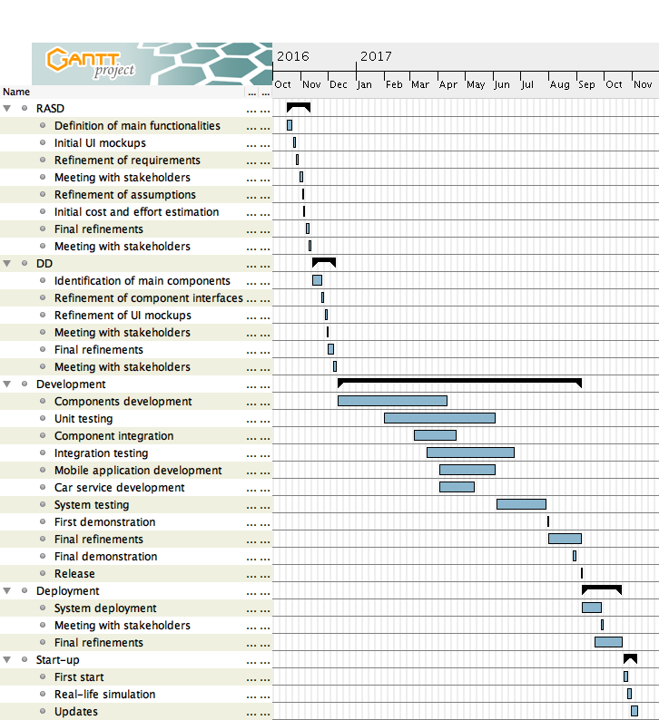

Called my partners Bob and Carl for alphabetical fashion, following is the chart representing the resource allocation among the group members. Please find the high-resolution version at the following link: <https://github.com/alfredo-f/electric-car-sharing/blob/master/releases/PPD/Charts/PEJ-Gantt-Resources.png>

Note that the tasks granularity provides some overlapping within same person’s assignment, inevitable for such a small team during the actual development phase.

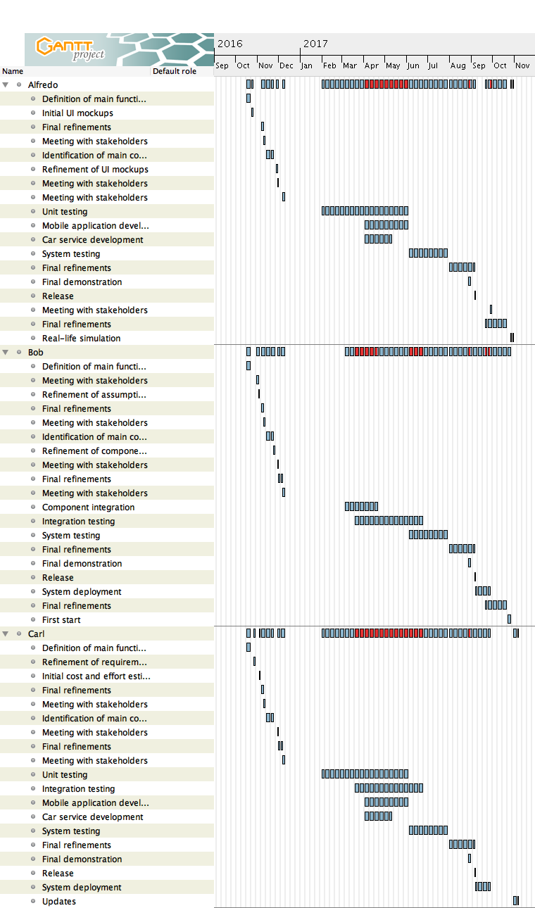

# Risk management

Risk analysis for projects designed to be deployed and maintained in real-world scenarios typically addresses what the RASD assumptions have left as margins of weakness reflecting the possible contexts and cases that occur on a predictable and unpredictable basis.

As a single-person group project, the set of deliverables this document belongs to is built up onto very strong assumptions, especially regarding customers’ behavior, which in many cases do not reflect what can occur on a daily basis in real-world scenarios. These assumptions were necessary to keep the project complexity at a level manageable by a single person (see Effort section).

This leads to the natural conclusion that analysis and solution proposal concerning every possible risky case related to this project real-world deployment would produce a paragraph of the length equivalent to a complete project developed and curated by two or more people.

As such, following are some of the risks the RASD assumptions were meant to address and solution outlines:

* Customers may not leave cars under secure conditions, i.e. with open doors or windows, ignited engine, outside parking lines or within unauthorized ones, leave a passenger inside (therefore the car should not perform the automated lock);

cars malfunctioning may stop them in unsafe areas and need manual intervention;

cars may run out of battery in the middle of the street, causing not only traffic circulation issues but also criminal prosecutions against the company itself for not having employed supervisors.

→ Field operators with administrators privileges should be notified and be able to access a subsystem, part of the system to be, where delete reservations, locate cars, not charge a ride performed by the field operator with a PowerEnJoy car, or employ another set of cars to be managed by the subsystem and distinguished from the customers’ cars;

* To notify field operators and keep communicating with the system, cars should be equipped with an independent Internet connection, which Android Auto, the state-of-the-art most advanced car system available, does not support relying solely onto the customer’s smartphone Internet connection (which can be turned off at any time and give a car control without any sort of limitation).

→ The only possible solution is developing a proprietary car system which constitute a huge initial investment costs.

* Cars distribution throughout the city may happen to be uneven, leaving at some point specific areas unserved by available cars.

→ The system should compute accurately and in real-time car locations, and prevent customers to leave cars where they are not allowed to, calculating routes and providing visual directions onto the car screen.

# Effort

* 16 January 2016: **1 h**
* 18 January 2016: **1,6 h**
* 20 January 2016: **2,2 h**
* 21 January 2016: **3,1 h**
* 22 January 2016: **3,3 h**

**11,2 h**

Following is the report of the total hours required for this project spent a single-person group:

|  |  |
| --- | --- |
| Document | Effort |
| Requirements Analysis and Specifications Document (RASD) | **63,4 h** |
| Design Document (DD) | **78,3 h** |
| Integration Test Plan Document (ITPD) | **23,9 h** |
| Project Plan Document (PPD) | **11,2 h** |
| Code Inspection Document | **6,3 h** + TBD |
| Total | **183,1 h** |

# Changelog

* v1.0